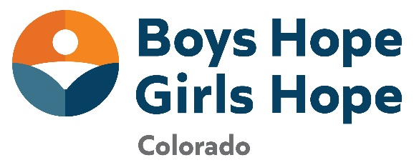
FOR IMMEDIATE RELEASE
Contact: Angie Hager, Development Officer
Boys Hope Girls Hope Colorado ahager@bhgh.org
3090 S Jamaica Ct. #212
Aurora, CO 80014
Boys Hope Girls Hope of Colorado Presents KLS Scholarship
Brand New Scholarship for Boys Hope Girls Hope scholars introduced and awarded.
November 6, 2024 – Boys Hope Girls Hope of Colorado has provided scholarships to its first recipients of the KLS Collegiate Scholarship Fund. Ten Boys Hope Girls Hope collegians and/or soon to be collegians were recently awarded a brand-new financial scholarship to continue their post-secondary educational journey.
Three types of academic scholarships were awarded based on the following criteria:
- Boys Hope Girls Hope of Colorado high school scholars who are pursuing a degree in business, mathematics and/or engineering.
- Boys Hope Girls Hope of Colorado collegians who are majoring in computer science and/or engineering.
- Boys Hope Girls Hope of Colorado collegians who have demonstrated exceptional academic excellence in any field of study.

All KLS Scholarships are renewable based on course load, GPA and engagement with Boys Hope Girls Hope of Colorado programming.
The KLS Scholarship Fund is also providing one need-based scholarship awarded to a Boys Hope Girls Hope of Colorado collegian who has circumstances beyond his or her control. Scholarships in all categories were awarded this past semester and will continue to be awarded twice a year at the beginning of each semester.
The KLS Scholarship Fund is named after Kent L. Swanson of Cherry Hills Village (December 5, 1944-March 1, 2024). Swanson was a transformational leader and longtime supporter for Boys Hope Girls Hope of Colorado, serving as Board Chair from the early to mid 2000s. For over twenty-three years, his commitment to the organization has impacted hundreds of scholars and collegians. He added a Girls Hope home, added an Academy, helped with the transition out of the residential program and was always looking to expand and serve more scholars and collegians.
“I love these kids. Makes our efforts to help them one of the most gratifying things we do,” was a recent email received from Swanson before his passing. Boys Hope Girls Hope of Colorado thanks the Swanson Family for their dedication to helping youth achieve their dreams and ignite hope for their future through the KLS Scholarship Fund.
###

About Boys Hope Girls Hope
The mission of Boys Hope Girls Hope is to nurture and guide motivated young people in need to become well-educated, career-ready men and women for others. With fourteen locations spread across the United States, Mexico, and Guatemala, Boys Hope Girls Hope addresses the opportunity gap at-risk youth entering high school face through provision of academic and personal support in a setting where all belong.
The Colorado affiliate supports scholars through two programs which provide a continuum of care. The Academy Program connects with motivated high school scholars who navigate systemic barriers to opportunity through touchpoints four to five times a week, college-preparatory support, life skills training, scholarships, and access to internships. The close-knit sense of community creates a safety net and an environment where young men and women can thrive. The College Program tracks collegians through the postsecondary journey into the launch of their career postgrad.
All scholars and collegians are first-generation and/or low-income youth that participate in the program. For more information, please visit www.bhghcolorado.org

