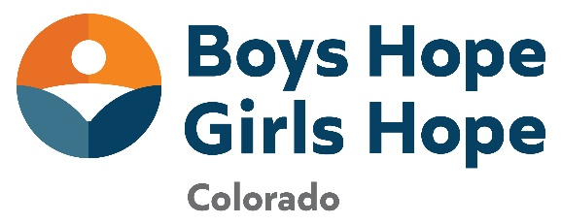
FOR IMMEDIATE RELEASE
Contact: Angie Hager, Development Officer
Boys Hope Girls Hope Colorado ahager@bhgh.org
3090 S Jamaica Ct. #212
Aurora, CO 80014
Boys Hope Girls Hope Collegians Venture to New Opportunities
Boys Hope Girls Hope collegians ready to start their post-secondary journey.
August 26, 2024 – Fifty-seven Boys Hope Girls Hope collegians will begin and/or continue their post-secondary educational journey in the next couple of weeks. 93 percent of these collegians are first generation students. Boys Hope Girls Hope not only equips high school scholars for the post-secondary path through ongoing programming and special enrichment activities, but also extends emotional, financial, and educational assistance to collegiate scholars. The impact of this comprehensive support is evident in the fact that 100% of Boys Hope Girls Hope scholars who graduate from high school proceed to college and/or an alternative post-secondary school. Boys Hope Girls Hope collegians benefit from networking opportunities, mentoring, career guidance, service initiatives, and leadership programs, ensuring their continued success during and after college.
“Boys Hope Girls Hope continues to provide me with the resources to be successful. Going into college I feel more confident and ready. I am eternally grateful for the Program Managers at BHGH that check in on me to make sure that I am on track in school,” said incoming college freshman, Jasline, who will be attending Grinnell College in Iowa this fall.

Over 2 million dollars of scholarships and need based merit was provided to the 2024 Boys Hope Girls Hope high school graduating class alone, to attend post-secondary institutions. Scholarships awarded include: Daniels Scholarship, Questbridge Scholarship, Aurora Gives Scholarship, and APS Foundation Scholarship funds Current Boys Hope Girls Hope collegians also receive scholarships through the Boys Hope Girls Hope Scholarship Program, totaling over $165,000 and of these students 93% contain a debt load of less than $5,000 per year.

“As a low-income student, college would not have been an option without the help of Boys Hope Girls Hope and scholarships,” said Boys Hope Girls Hope freshman collegian, Aline, who will be attending Smith College in Massachusetts this fall. Aline was one of two Boys Hope Girls Hope scholars who received a Questbridge Scholarship totaling $86,000. Boys Hope Girls Hope also provided her with an additional scholarship dollars.

Boys Hope Girls Hope of Colorado collegians will be attending the following institutions in the 2024/2025 academic year: California State University - Monterey Bay, Colorado Mesa University, Colorado School of Mines, Colorado State University, Community College of Aurora, Dartmouth College, Grand Canyon University, Grinnell College, Loyola University – Chicago, Metropolitan State University of Denver, Saint Louis University, Santa Clara University, Smith College, University of Colorado – Denver, University of Colorado Anschutz Medical Campus, University of Colorado Boulder, University of Colorado Boulder, University of Denver, University of San Francisco, University of Southern California, and the University of Virginia.
###
About Boys Hope Girls Hope
The mission of Boys Hope Girls Hope is to nurture and guide motivated young people in need to become well-educated, career-ready men and women for others. Boys Hope Girls Hope addresses the opportunity gap at-risk youth entering high school face through provision of academic and personal support in a setting where all belong.
With fourteen locations spread across the United States, Mexico, and Guatemala, Boys Hope Girls Hope, including the Colorado affiliate, supports scholars which provide a continuum of care. The Academy Program connects with motivated high school scholars who navigate systemic barriers to opportunity through touchpoints four to five times a week, college-preparatory support, life skills training, scholarships, and access to internships. The close-knit sense of community creates a safety net and an environment where young men and women can thrive. The College Program tracks collegians through the postsecondary journey into the launch of their career postgrad.
All scholars and collegians are first-generation and/or low-income youth that participate in the program. For more information, please visit www.bhghcolorado.org

